

Center of Information Technology and Scientific Computing

Department of Software Engineering

Database Administration (DBA)

*Lab Assignment documentation*

*Section-2*

*Group members:*

* *Henok Addis … ATR/6271/09*
* *Kibrleab enyew …. ATR/6688/09*
* *Habib jemal …..ATR/9805/09*

Submitted to Mr. Getasew

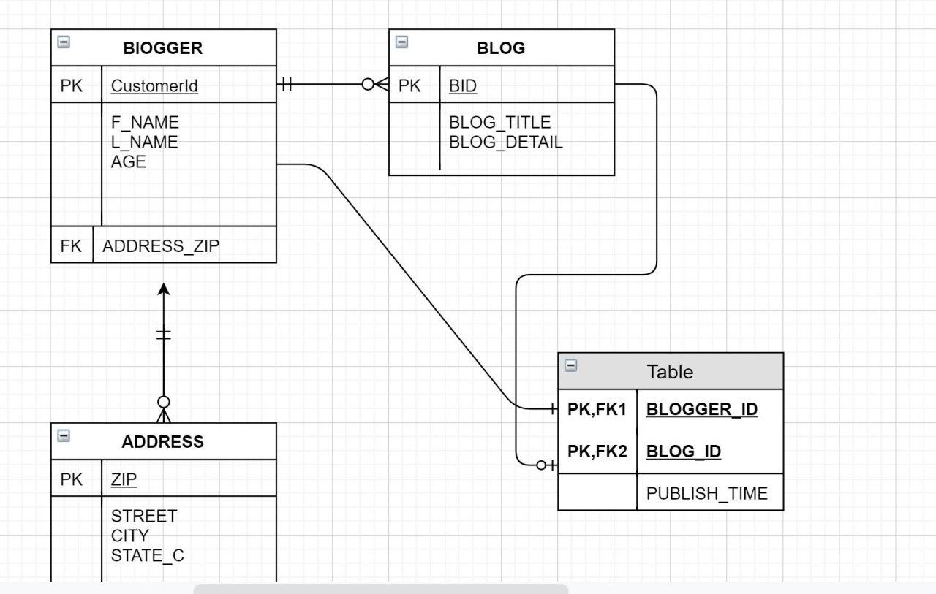

Figure 1:uml diagram

Answers for questions:

1. DB_BLOCK_SIZE specifies (in bytes) the size of Oracle database blocks. Typical values are 4096 and 8192. The value of this parameter must be a multiple of the physical block size at the device level.

The value for DB_BLOCK_SIZE in effect at the time you create the database determines the size of the blocks. The value must remain set to its initial value.

For Real Application Clusters, this parameter affects the maximum value of the FREELISTS storage parameter for tables and indexes. Oracle uses one database block for each freelist group. Decision support system (DSS) and data warehouse database environments tend to benefit from larger block size values.

1. Every Oracle **database** contains a **tablespace** named SYSTEM, which Oracle creates automatically when the **database** is created. The SYSTEM **tablespace is always online when the database is open.**
2. There are two types of tablespace

Locally managed tablespace: locally managed tablespace > information of your extent (free or used, size etc..) is stored in the header of datafile.

Dictionary managed tablespace : dictionary managed tablespace > means the information of your extent is stored is data dictionary (system tablespace ) which effect in performance so oracle recommend locally managed tablespace if ur system tablespace locally managed tablespace then you cannot create dictionary managed tablespace in your database ok but if your system tablespace is dictionary managed then you can make both ok any doubt then ask me.

1. Oracle uses the term "Smallfile" to designate the tablespaces traditionally used for long time. A Bigfile Tablespace is a tablespace containing a single very large data file. ... Bigfile tablespace contains only one file, whereas a traditional tablespace (smallfile type) can contain up to 1,022 files.
2. [**Normalization**](https://www.geeksforgeeks.org/database-normalization-normal-forms/)**:**  
   Normalization is the method used in a database to reduce the data redundancy and data inconsistency from the table. It is the technique in which Non-redundancy and consistency data are stored in the set schema. By using normalization the number of tables is increased instead of decreased.

[**Denormalization**](https://www.geeksforgeeks.org/denormalization-in-databases/)**:**  
Denormalization is also the method which is used in a database. It is used to add the redundancy to execute the query quickly. It is a technique in which data are combined to execute the query quickly. By using denormalization the number of tables is decreased which oppose to the normalization.

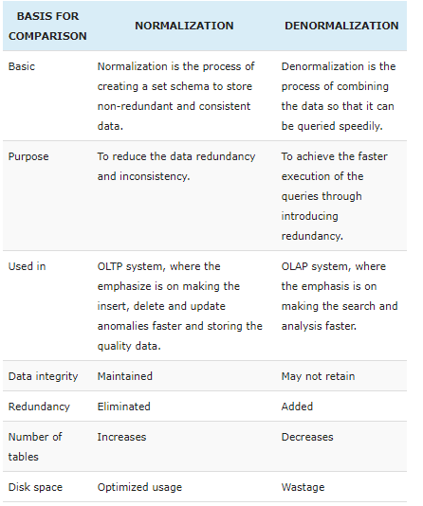

1. We can normalize by taking the primary key of two tables and form another table with two foreign keys from two tables. i.e. by taking the primary key of both tables.
2. A **view** is a virtual **table**. A **view** consists of rows and columns just like a **table**. The **difference between** a **view** and a **table** is that **views** are definitions built on top of other **tables** (or **views**), and do not hold data themselves. If data is changing **in the** underlying **table**, the same change is reflected **in the view**. A **table** contains data, a **view** is just a SELECT statement which has been saved in the database (**more or** less, depending on your database). The advantage of a **view** is that it can join data from several **tables** thus creating a new **view** of it. A table cluster is a group of tables that share common columns and store related data in the same blocks. When tables are clustered, a single data block can contain rows from multiple tables. For example, a block can store rows from both the employees and departments tables rather than from only a single table. The cluster key is the column or columns that the clustered tables have in common. For example, the employees and departments tables share the department_id column You specify the cluster key when creating the table cluster and when creating every table added to the table cluster. The cluster key value is the value of the cluster key columns for a particular set of rows. All data that contains the same cluster key value, such as department_id=20, is physically stored together. Each cluster key value is stored only once in the cluster and the cluster index, no matter how many rows of different tables contain the value.
3. **Because Creating** a unique **clustered index** on a **view** improves query performance because the **view is** stored in the database in the same way a table with a **clustered index is** stored. The query optimizer may use indexed views to speed up the query.

**Because Views** are used for security purposes because **they** provide encapsulation of the name of the table. Data is in the virtual table, not stored permanently. **Views** display only selected data. **We** can also use **Sql** Joins in the Select statement in deriving the data for the **view.**

**Because Indexes are used in Oracle** to provide quick access to rows in a table. **Indexes** provide faster access to data for operations that return a small portion of a table's rows. Although **Oracle** allows an unlimited number of **indexes** on a table, the **indexes** only help if they are **used** to speed up queries

1. When the Oracle Database starts an instance, it goes through the following stages: NOMOUNT, MOUNT, and OPEN.

1) NOMOUNT stage : In the NOMOUNT stage, Oracle carries the following steps:

* First, search for a server parameter file in the default location. You can override the default behavior by using the SPFILE or PFILE parameters in the STARTUP command.
* Next, read the parameter file to get the values of the initialization parameters.
* Then, allocate the system global area (SGA) based on the initialization parameter settings.
* After that, start the Oracle background processes such as SMON, PMON, and LGWR.
* Finally, open the alert log and trace files and record all explicit parameters to the alert log in the valid parameter syntax.

At the NOMOUNT stage, Oracle does not associate the database with the instance.

2) MOUNT stage

In the MOUNT stage, Oracle associates a database with an instance. In other words, the instance mounts the database.

The instance carries the following steps to mount a database:

* First, get the name of the database control files specified in the CONTROL_FILE initialization parameter.
* Second, open the control files.
* Third, find the name of data files and the online redo log files.

When a database is mounted, the database is only available to database administrators, not all users.

3) OPEN stage

In the OPEN stage, Oracle performs the following actions:

* First, open the online data files in [tablespaces](https://www.oracletutorial.com/oracle-administration/oracle-tablespace/) other than the undo tablespaces.
* Then, select an undo tablespace. The instance uses default undo tablespace if an undo tablespace is specified in the UNDO_TABLESPACE initialization parameter. Otherwise, it will select the first available undo tablespace.
* Finally, open the online redo log files.

When Oracle opens a mounted database, the database is available for normal operations.

The following picture illustrates the Oracle database startup process:

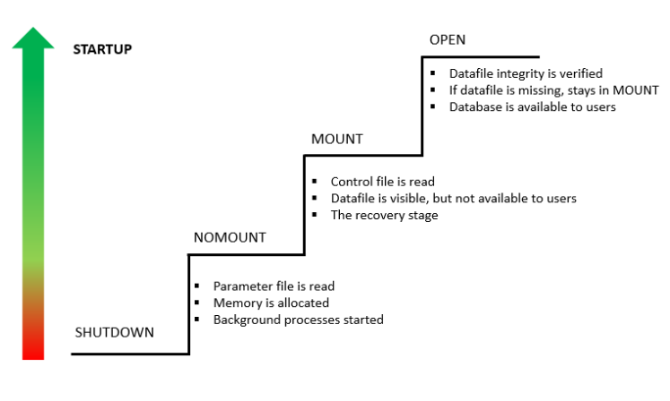

* Therefore, the **instance recovery**​ (rollback forward) stage is the mount stage.

1. A control file is a small binary file that records the physical structure of the database and includes: The database name. Names and locations of associated datafiles and online redo log files. The timestamp of the database creation. The current log sequence number.

Parameter file is a text or binary to store the database initialization parameters. The oracle instance reads the parameter file during startup which are then used to control the behavior of database instance and many other aspects as well.

In Oracle9c, a new feature called SPFILE (server parameter file) was introduced. SPFILE is a binary file that contains the same information as the old PFILE. ... By default, if you do not specify PFILE in your STARTUP command, Oracle will use server parameter file (SPFILE).

### SHUTDOWN ABORT

The SHUTDOWN ABORT is not recommended and only used on some occasions. The SHUTDOWN ABORT has a similar effect as you unplug the power of the server. The database will be in an inconsistent state. Therefore, you should never use the SHUTDOWN ABORT command before backing up the database. If you try to do so, you may not be able to recover the backup.

It is recommended to use the SHUTDOWN ABORT only when you want to shut down the database instantaneously. For example, if you know a power shutdown is going to happen in a minute or you experience some problems when [starting up a database instance](https://www.oracletutorial.com/oracle-administration/oracle-startup/).

The SHUTDOWN ABORT proceeds with the fastest possible shutdown of the database. However, it requires instance recovery on the next database startup.

### SHUTDOWN IMMEDIATE

The SHUTDOWN IMMEDIATE is the most common and practical way to shut down the Oracle database.

The SHUTDOWN IMMEDIATE does not wait for the current users to disconnect from the database or current transactions to complete.

During the SHUTDOWN IMMEDIATE, all the connected sessions are disconnected immediately, all uncommitted transactions are rolled back, and the database completely shuts down.

After issuing the SHUTDOWN IMMEDIATE statement, the database will not accept any new connection. The statement will also close and dismount the database.

Unlike the SHUTDOWN ABORT option, the SHUTDOWN IMMEDIATE option does not require an instance recovery on the next database startup.

The following table illustrates the differences between the shutdown modes:

1. Describe different types of lock mode and lock level ?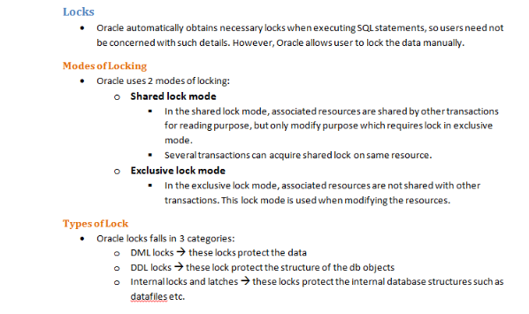

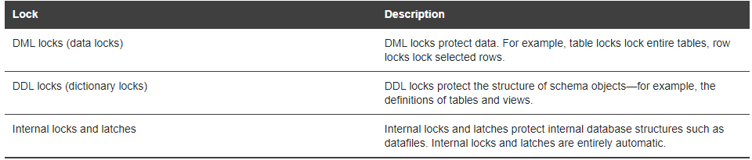

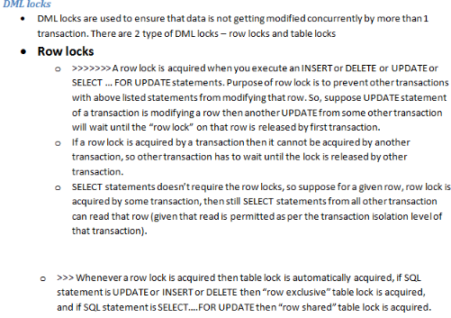

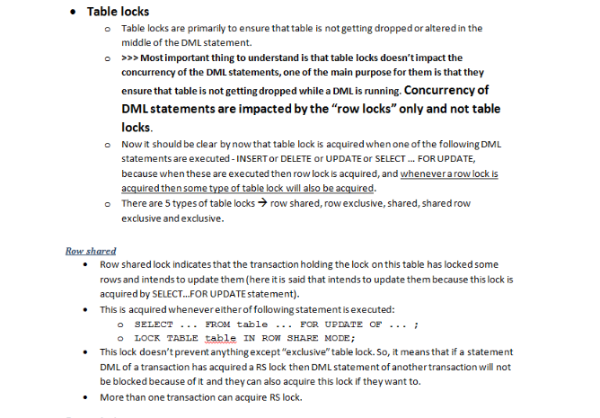

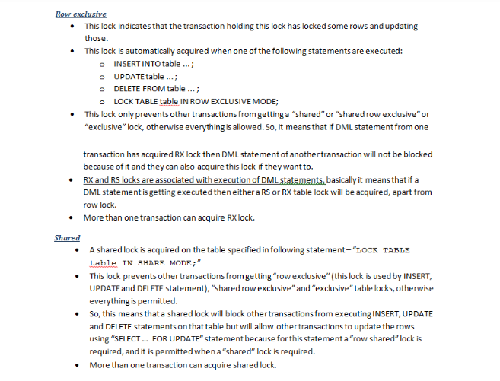

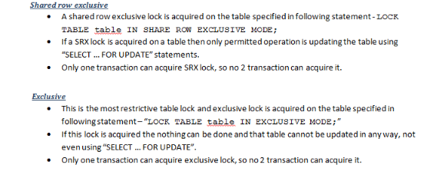

1. the system change number (SCN) is Oracle's clock - every time we commit, the clock increments. The SCN just marks a consistent point in time in the database. A checkpoint is the act of writing dirty (modified blocks from the buffer cache to disk. The database ALWAYS has transactions going on, ALWAYS